**Practical no 2**

* Write a program for genrating regular expression for regular grammar.
* 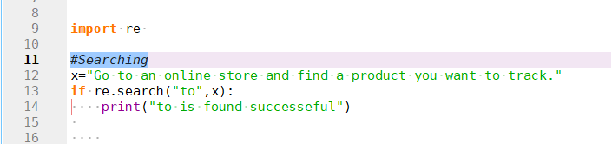Searching :
* 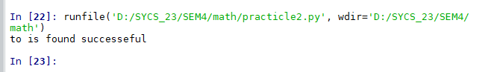OUTPUT:
* Find All :

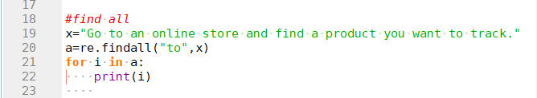

* 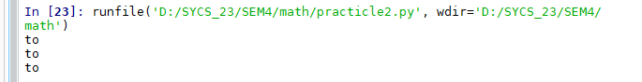OUTPUT:
* 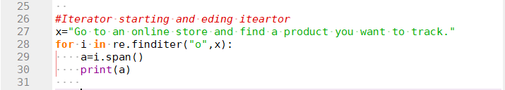Iterator starting and eding iteartor :
* OUTPUT:

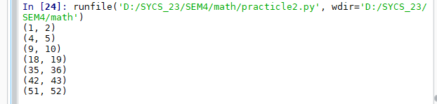

* 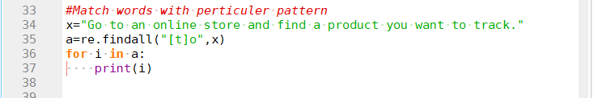Match words with perticuler pattern :
* OUTPUT:

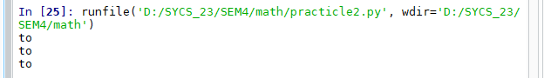

* Match series of range of character :

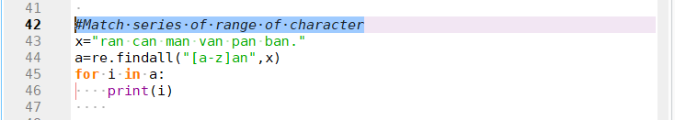

* OUTPUT:

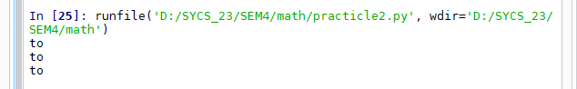

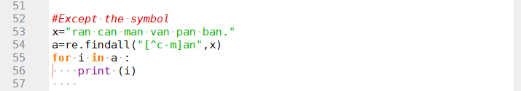

* Except the symbol
* OUTPUT:

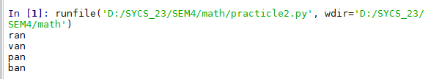

* Replace the string :

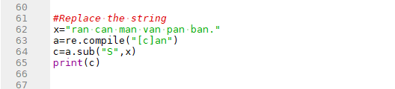

* OUTPUT:

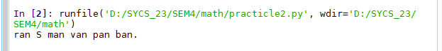

* 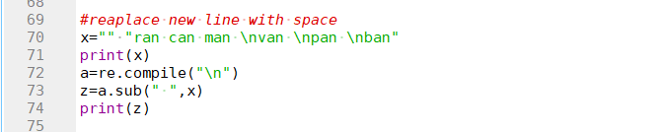Reaplace new line with space :
* 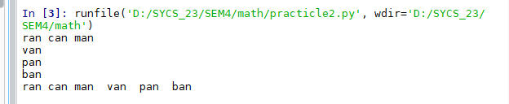OUTPUT:
* 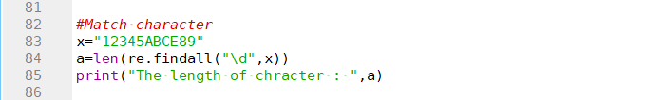Match character :

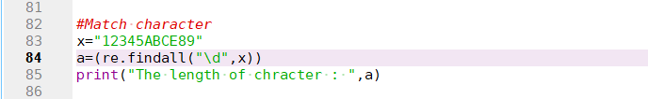

* OUTPUT:

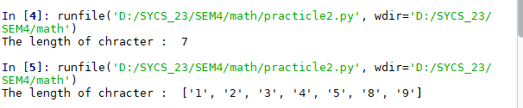

* Multiple matches :

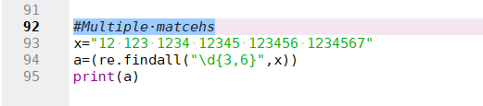

* OUTPUT:

